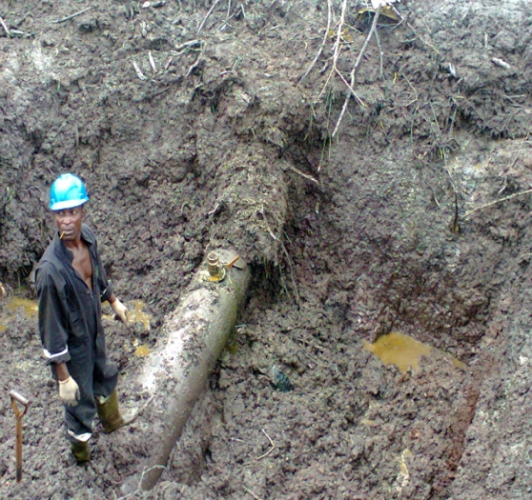
SPILL POINT (3’’ VALVE INSTALLED ON THE PIPE LINE)
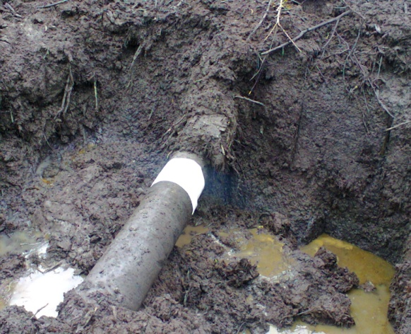
REPAIRED SPILL POINT

